Multiple-choice section

|  |  |  |  |  |  |  |  |  |  |  |  |  |
| --- | --- | --- | --- | --- | --- | --- | --- | --- | --- | --- | --- | --- |
| Question | 1 | 2 | 3 | 4 | 5 | 6 | 7 | 8 | 9 | 10 | 11 | 12 |
| Answer | D | D | A | C | A | B | D | B | D | B | B | B |

Question 1 [6.1]

D

Find the point on the graph that is to the right of the cup and lower down than the saucepan:  
oven tray.

Question 2 [6.1]

D

Stationary sections are those where the graph is horizontal: sections *C*, *E* and *G*.

Question 3 [6.2]

A

Any coordinate with a *y*-value of 2 will lie on the line *y* = 2; e.g. (5, 2)

Question 4 [6.2]

C

Each column in the table represents one coordinate.

Question 5 [6.2]

A

Any coordinate with a *x*-value of 1 will lie on the line *x* = 1; e.g. (1, 0)

Question 6 [6.3]

B

*y* = 2*x* + 3

Substituting the *x*-coordinate of each point into the equation gives the corresponding *y*-coordinate.

Question 7 [6.2]

D

For , where , so the point (2, 3) is on the line.

Question 8 [6.2]

B

Thelinewithequation crosses the *x*-axis at (-2, 0).

Question 9 [6.2]

D

*x* = 5

Gradient of a line parallel to the *y*-axis is not defined.

Question 10 [6.2]

B

*x* +3*y* = -1

Question 11 [6.2]

B

The line with equation *y* = -5 is parallel to the *x*-axis and so is flat.

Question 12 [6.4]

B

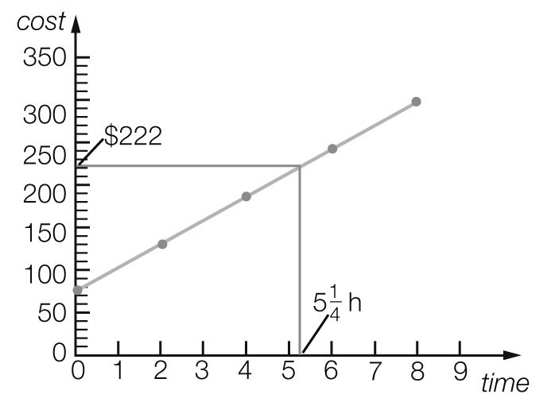

Actual value = $222 ∴ Closest to $220

Multiple-choice total marks: 12

Short answer section

Question 13 5 marks [6.2]

(a) Lines with a *positive* gradient *slope* up to the right and lines with a *negative* gradient *slope* up to the *left*.

(b) The *x*-intercept is where a line crosses the *x-axis* and the *y-intercept* is where a line crosses the *y*-axis.

(c) The *gradient* of a line is a measure of its steepness.

(d) When points on a graph make a *straight line* then the relationship between the variables is *linear*.

(e) The point (0, 0) is the *origin* of the *Cartesian* plane.

Question 14 2 marks [6.2]

Horizontal line is *y* = -7

Vertical line is *x* = 5

Question 15 3 marks [6.1]

(a) Arm span and hand span (the axis labels)

(b) Paul (the lowest point on the graph)

(c) Tracey (the point furthest to the right on the graph)

Question 16 2 marks [6.1]

(a) *D*. Horizontal lines show no movement.

(b) *C*. Steeper lines show faster speeds.

Question 17 3 marks [6.2]

|  |  |  |  |  |  |  |  |
| --- | --- | --- | --- | --- | --- | --- | --- |
| *x* | -3 | -2 | -1 | 0 | 1 | 2 | 3 |
| *y* | -9 | -7 | -5 | -3 | -1 | 1 | 3 |

Question 18 4 marks [6.3]

|  |  |  |  |  |  |  |  |
| --- | --- | --- | --- | --- | --- | --- | --- |
| *x* | -3 | -2 | -1 | 0 | 1 | 2 | 3 |
| *y* | -9 | -6 | -3 | 0 | 3 | 6 | 9 |

So *y* = 3*x*

Question 19 6 marks [6.3]

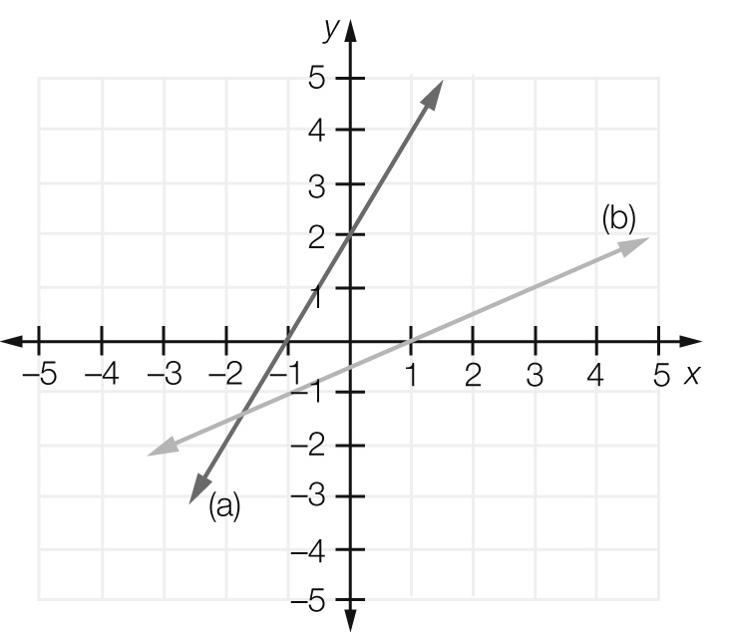

(a) *y*-intercept = 2, 

(b) *y*-intercept = -0.5, 

Question 20 4 marks [6.3]

(a)  (b) 

Question 21 2 marks [6.2]

*x*-intercept = (, 0)

*y*-intercept = (0, )

Question 22 3 marks [6.2]

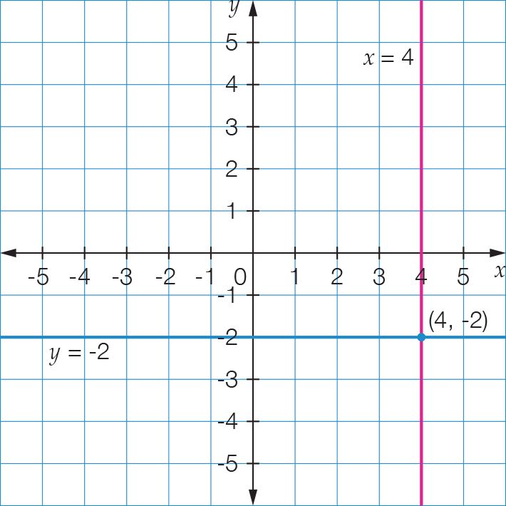

Point of intersection: (4, -2)

Question 23 1 mark [6.3]

Line has gradient of zero and passes through (-5, 7). Rule: 

Question 24 1 mark [6.3]

Vertical line through (3, -2). Rule: 

Short answer total marks: 36

Extended answer section

Question 25 5 marks [6.1]

(a)

|  |  |  |  |  |  |
| --- | --- | --- | --- | --- | --- |
| Distance from start (km) | 0 | 600 | 600 | 1000 | 1000 |
| Petrol in tank (L) | 80 | 20 | 80 | 30 | 70 |

(b)

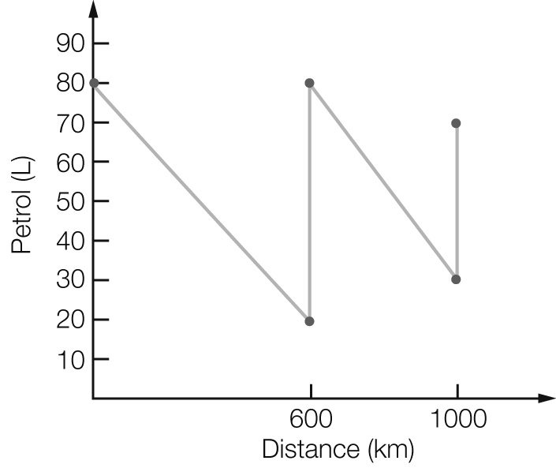

(c) The car used 60 L over 600 km (10 L/100 km) for the first part of the trip, and 50 L over 400 km (12.5 L/100 km) for the second part of the trip.

(d) The line falls more steeply for the second part.

Question 26 5 marks [6.3]

(a)

|  |  |
| --- | --- |
| Number of pentagons  (*p*) | Number of matches  (*m*) |
| 1 | 5 |
| 2 | 9 |
| 3 | 13 |
| 4 | 17 |
| 5 | 21 |

(b) 

(c)

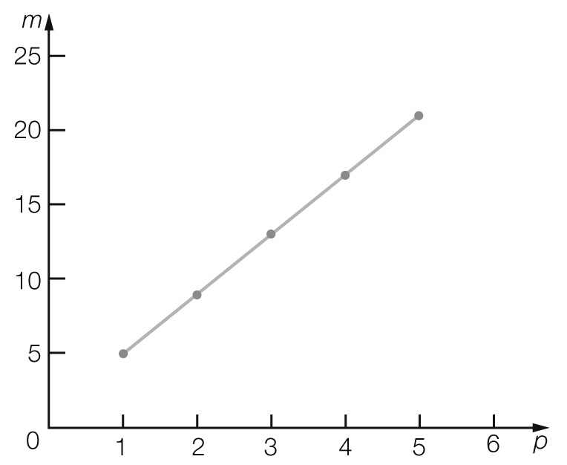

(d)

For *p* = 10, *m* = 4 × 10 + 1

= 41 matches

Question 27 4 marks [6.3]

(a) *C* = 40 + 30*t*

(b)

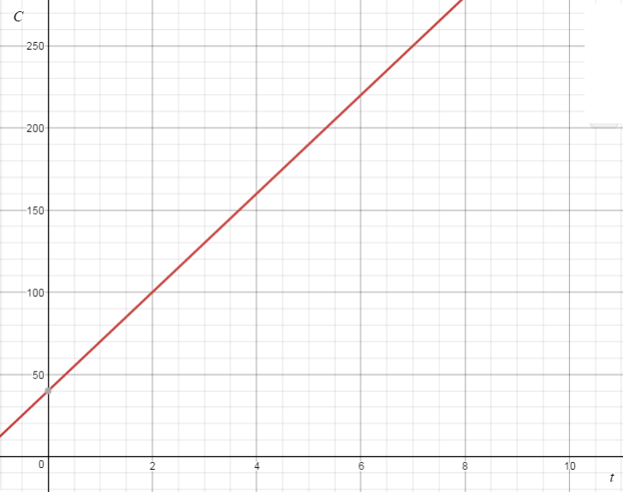

(c) *C* = 40 + 30*t*

= 40 + 30 × 4.5

= $175

Question 28 4 marks [6.4]

(a) $2.25

(b) 

(c) 



Question 29 5 marks [6.4]

(a)

|  |  |  |  |  |  |  |  |
| --- | --- | --- | --- | --- | --- | --- | --- |
| Number of miles | 0 | 5 | 10 | 15 | 20 | 25 | 50 |
| Number of kilometres | 0 | 8 | 16 | 24 | 32 | 40 | 80 |

(b) *k* = 1.6*m*, or 5*k* = 8*m*, or *k* = *m*

(c)

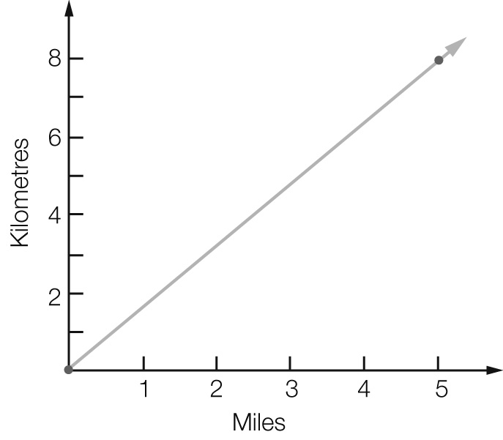

(d) *k* = 1.6*m*

*k* = 1.6 × 8

= 12.8 miles

(e) *k* = 1.6*m*



= 62.5 miles

Extended answer total marks: 23

TOTAL test marks: 71